## **Lab 25: Android Rating Bar**

# **Introduction**

A user interface widget called Android RatingBar is used to collect ratings from clients or users. Users can rate items by clicking on the stars in this SeekBar and ProgressBar extension, which displays star ratings.

**Let’s get Started:**

In this exercise, we will learn how to create Rating Bar in our Android application using Kotlin as our programming language.

**Step 1:** open **activity_main.xml** file from **\res\layout** folder path and write the code like as shown below.

**activity_main.xml**

*<?*xml version="1.0" encoding="utf-8"*?>*<LinearLayout  
 xmlns:android="http://schemas.android.com/apk/res/android"  
 xmlns:tools="http://schemas.android.com/tools"  
 android:id="@+id/container"  
 android:layout_width="match_parent"  
 android:layout_height="match_parent"  
 tools:context=".MainActivity"  
 android:orientation="vertical"  
 android:gravity ="center">  
  
 <RatingBar  
 android:id="@+id/rBar"  
 android:layout_width="wrap_content"  
 android:layout_height="wrap_content"  
 android:stepSize="0.5"  
 android:theme="@style/Widget.AppCompat.RatingBar"  
 android:backgroundTint="@color/purple_200"  
 android:numStars="5"/>  
  
 <Button  
 android:id="@+id/button"  
 android:layout_width="wrap_content"  
 android:layout_height="wrap_content"  
 android:text="Click to Submit Rating" />  
</LinearLayout>

**Step 2:** Open main [activity](https://www.tutlane.com/tutorial/android/android-activity-lifecycle) file **MainActivity.kt** and write the code like as shown below.

**MainActivity.kt**

**package** com.example.demopluralsightratingbar  
  
**import** android.os.Bundle  
**import** android.support.v7.app.AppCompatActivity  
**import** android.widget.Button  
**import** android.widget.RatingBar  
**import** android.widget.Toast  
  
**class** MainActivity : AppCompatActivity() {  
  
 **override fun** onCreate(savedInstanceState: Bundle?) {  
 **super**.onCreate(savedInstanceState)  
 setContentView(R.layout.*activity_main*)  
  
 **val** rBar = findViewById<RatingBar>(R.id.*rBar*)  
 **if** (rBar != **null**) {  
 **val** button = findViewById<Button>(R.id.*button*)  
 button?.setOnClickListener **{  
 val** msg = rBar.*rating*.toString()  
 Toast.makeText(**this**@MainActivity,  
 **"Rating is: "**+msg, Toast.*LENGTH_SHORT*).show()  
 **}** }  
 }  
}

**Step 3: Check Output on Android Emulator and it should look like as given below.**

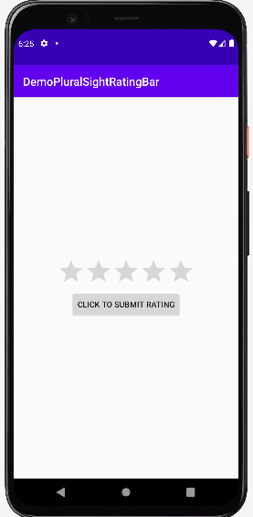 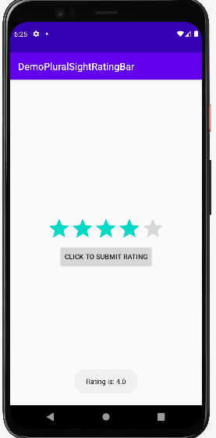

**Voila!!** We have successfully completed this lab.